Cell Biology Test Review Questions

- Complementary base paring occurs between each base pair (A-T, C-G), which always lie opposite from each other on their own sugar-phosphate backbones. The base pairing is achieved via hydrogen bonding between each base pair. When DNA replicates, it unzips itself via an enzyme called helicase. The joining of adjacent nucleotides in DNA replication occurs when the phosphate group from one-nucleotide bonds with the sugar group from another nucleotide. This process is achieved via an enzyme called polymerase, which also ‘proofreads’ the DNA for any errors.
- Replicate the following sequence:

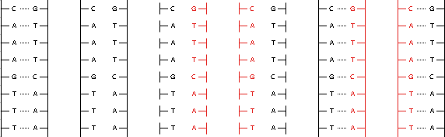
- An enzyme called polymerase, which is involved in combining nucleotides and ‘re-zipping’ the DNA, is involved in ‘proofreading’ the DNA. If any error occurs, the polymerase removes the incorrect nucleotide and replaces it with the correct one.
- ATP is an energy source for the cell, which is involved in anaerobic cellular respiration. The energy of ATP is stored in the high-energy bonds of the third phosphate group. Energy is released from ATP when the third phosphate’s bond is broken, which releases energy in the form of kinetic and heat energy. Depending on the function of the cell, the energy from the release of the third phosphate in ATP is harvested in different manners.
- Hydrogen bonding is where the oxygen atoms of one molecule are attracted, by way of London forces, to a nearby hydrogen atom. In proteins, this accounts for the secondary structure, the alpha helix. In DNA, hydrogen bonding between each base pair joins the two separate strands of the DNA double helix.

